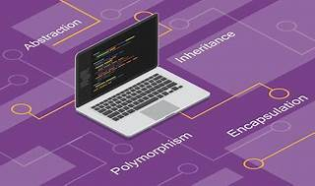

Explore

**Object-Oriented Programming (OOP)** is a fundamental programming paradigm that structures software using **classes** and **objects**. [It allows developers to create reusable code blueprints (classes) and instantiate individual instances (objects) with specific properties and methods1](https://www.educative.io/blog/object-oriented-programming).

Here are **five free resources** where you can learn more about OOP:

1. **W3Schools Java OOP Tutorial**[: Covers the basics of OOP in Java, including classes, objects, and advantages over procedural programming](https://www.educative.io/blog/object-oriented-programming)[Learn here2](https://www.w3schools.com/java/java_oop.asp).
2. **freeCodeCamp C++ OOP Video Course**[: A comprehensive video course on implementing OOP concepts using C++](https://www.educative.io/blog/object-oriented-programming)[Watch here3](https://www.freecodecamp.org/news/learn-object-oriented-programming-oop-in-c-full-video-course/).
3. **Udemy Java OOP Basics**[: Learn about classes, objects, constructors, and inheritance in Java](https://www.educative.io/blog/object-oriented-programming)[Enroll here4](https://www.udemy.com/course/java-oop-basics/).
4. **Udemy OOP in Python**[: Dive into Python’s OOP concepts, including classes, inheritance, and encapsulation](https://www.educative.io/blog/object-oriented-programming)[Explore here5](https://www.udemy.com/course/oop-in-python-mpb/).
5. **Medium Article on OOP Basics**[: Discover free courses for learning OOP with Java, Python, and JavaScript](https://www.educative.io/blog/object-oriented-programming)[Read here6](https://medium.com/swlh/5-free-object-oriented-programming-online-courses-for-programmers-156afd0a3a73).

Happy learning! 🚀